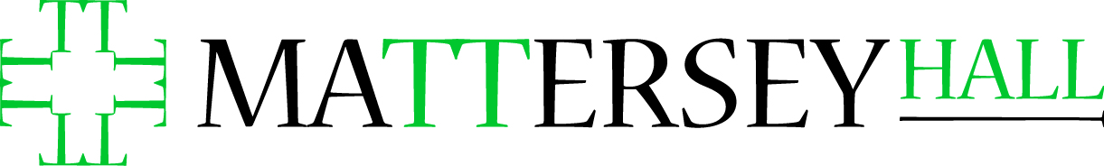
Dissertation Supervision Report
Supervisor:
Date:
Meeting Number: 1 2 3 4 5 6
Should there be any issues of a confidential nature that you would like to discuss further, please contact the dissertation coordinator.

1. Please briefly detail what was discussed.

2. Considering the current progression, please answer the following:
Does the student have a satisfactory outline? Yes / No
Does the student have a satisfactory bibliography? Yes / No
Is the student progressing well? Yes / No
If no to any of the above, please clarify below:

3. Any other comments

4. Signatures
Supervisor:

Student:

